FOUR-LINK REAR SUSPENSION OPERATING CHARACTERISTICS
Of primary importance is that the rear axle be centred in the chassis and perpendicular to the frame rails; that the locating points of the suspension bars be symmetrically mounted on the chassis and axle housing; and that the right and left bars be adjusted to equal lengths when installed. There’s much more to it than this – including setting the pinion angle, aligning the front suspension, determining the centre of gravity, plotting four-link intersecting points (instant centre) for various bar settings, and so on. The point is that the chassis, as a whole, must be correctly assembled and “baselined” before you can begin to “tune” it – the same as for tuning an engine.

The second feature to understand about chassis tuning is that the four-link does not operate, and should never be adjusted, by it self. In any suspended car, at least four potentially-adustable elements work in conjunction with each other: the springs, the shocks, the suspension locating bars or other attached geometry, and the relationship between front and rear suspension. This does not take into account other contributing factors such as tyre pressure and traction, torque converter/gear ratio, ballast (for shifting of the centre of gravity), and so on.
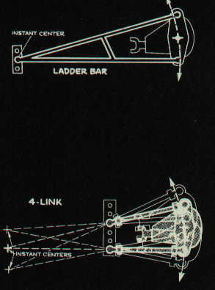
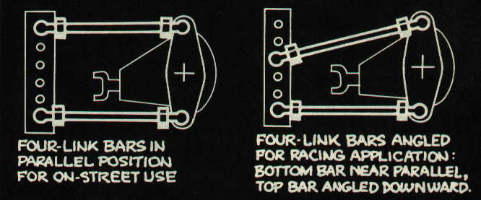
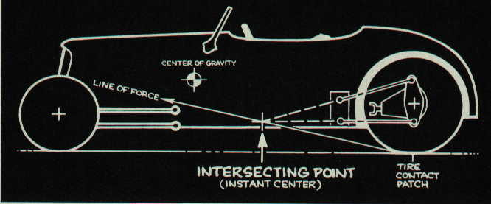

A line drawn (see above illustration) from the rear tyre contact patch through the instant centre of the rear suspension represents the “line of force” through which tyre motion is transferred to car motion. The instant centre is the point about which the rear end pivots as it moves up and down with the suspension. The instant centre of a ladder bar remains constant; that of a four-link change as the rear end moves. The shorter or more angled the bars, the greater the change.

Most confusion surrounding the rear suspension linkage (ladder bar/four-link) is in the action/reaction torque around the rear axle and its housing; the pinion “climbing” the ring gear, and the fact that the axle housing wants to rotate in the opposite direction of the rear wheels. With a ladder bar solidly attached to the rear end housing, and pivot the front end in a bracket somewhere on the chassis, the “counter-rotating” rear end housing appears to be imparting and upward force on the chassis at the ladder bar’s pivot point – “lifting” the chassis vertically at that point on acceleration. However, that would only happen if you tied the rear wheels solidly to the ground, and with enough engine torque the front of the car would lift and be rotated backwards. But that’s not really what is happening when a drag car is launched. The tyre is trying to push the car forward. It is pushing from the point where it contacts the ground. The centre of gravity of the car, however, is higher than this point. Inertia wants to keep the car where it is, rather than letting it move forward.

If the pushing force of the rear tyre, at the ground, is strong enough and rapid enough, it tends to "tip the car over' because it is pushing below the centre of gravity. Somebody used the analogy of pushing a refrigerator to explain this (see illustration next page). If you try to push a refrigerator across the floor, and you push it vigorously down near the bottom, it will tip over on top of you. This is partially what happens when you launch a car. Of course, the rotational torque about the rear axle helps tilt it, too.

The fact that a car is suspended (unlike a refrigerator) complicates things. For example, it allows the body to shift or tilt more easily (depending on spring and shock rates) as the inertia force (equal to the sprung weight of the car times the acceleration force) acts at the centre of gravity, in a direction opposite of acceleration (ie, to the rear). When the body shifts, this alters the location of the centre of gravity in relation to the rear tyre patch, changing things again.

But consider just the rear suspension for a moment. The axle is not mounted solidly to the frame. It is held in place by some sort of linkages and simply "floats" on the springs (leaf springs are linkages in themselves). These linkages determine a certain arc about which the rear axle swings as it moves up and down in the chassis. With ladder bars, the point about which it swings is obviously the front end of the bar, where it pivots in the frame bracket. This point about which the rear end pivots as it moves up and down is called the "instant centre" of the suspension.

Now here's the big point. Not only is the instant centre of the rear suspension the point about which it pivots, but it is also the point through which the rear tyre pushes the car. That is, the rear tyre pushes at the ground, but it also must push on the chassis, in order to move the car. The tyre is attached to the rear axle, and the rear axle is attached to the frame by the links or bars. The force that pushes the car forward is transmitted to the chassis by the rear axle connecting links. The rear end isn't pushing the front of the ladder bar up; the "line of force" that moves the car forward pushes from the tyre contact patch through the pivot point of the ladder bar. Thus it is pushing mostly forward, and partially up, at the same time. The angled line of force can be considered as horizontal (forward) and vertical (up) vectors. This is oversimplifying quite a bit, but it helps explain the dynamics of the launch.

I haven't mentioned anything about "tuning" the rear suspension, have I? It all has to do with where the links that position the rear-end attach (or pivot) on the chassis. In the case of a ladder bar, it is the actual pivot point at the front of the bar. With a four-link, it is the imaginary intersect point of the two bars that determines the actual instant centre about which the rear end pivots – and through which the pushing force from the tyre is transmitted to the chassis.

When you're building the chassis, you could attach the front of the bars most anywhere. You could mount them high or low, or make them long or short. In doing so, you change the relationship between the line of force that pushes the car, and the car's centre of gravity. Consider exaggerated examples. Let's say you have long ladder bars mounted low on the frame near the engine's bellhousing. The centre of gravity of the car is above this point, and slightly behind it. When the car launches, the inertia force (weight transfer) acts toward the rear at the centre of gravity. But the body/chassis is "hinged" (in a manner of speaking) at the ladder bar pivot point; so, as the tyre and ladder bar push the car forward, the inertia force tries to push it back, but actually swings the rear of the body down. This does transfer weight to the real wheels, which helps traction, and it is why American drag cars in the Sixties were jacked up in the front and used long ladder bars.

However, this arrangement – especially with the shorter bars common today – also tends to force the rear wheels and axle up, compressing the springs, which allows the rear of the body to drop. This condition is known as rear squat. Although it looks like you are transferring more weight to the rear tyres and increasing traction, you are actually lifting the rear tyres, and decreasing traction.

Chassis engineers talk about "anti-squat" at the rear on acceleration and use a traditional diagram to calculate "percentage of anti-squat" (see illustration next page). Because the weight (centre of gravity) of a typical road car is supported by the front and rear wheels, engineers draw a "100-percent anti-squat" force line from the rear tyre contact patch to the front wheel vertical centre-line, at the height of the centre of gravity. If the actual "line of force" for the car – the line from the rear tyre contact patch through the instant centre of the rear suspension – coincides with the 100-percent anti-squat line, then theoretically the rear suspension will neither lift nor drop, and the rear of the car will not rise or squat, as the car accelerates. That is, if the instant centre of the rear suspension lies anywhere on this line, the car will have 100-percent anti-squat. If the instant centre is anywhere below the line, the rear will squat (or, have a certain percentage – a fraction – of anti-squat). If the instant centre is above this line, it will have more than 100-percent anti-squat, which means the rear of the car will be pushed upwards by the suspension links as the car accelerates.

Look at this another way. If the suspension is trying to push the back of the car up, that's the same thing as saying it's trying to push the rear wheels and tyres down, against the track surface, which obviously increases bite. That's what this rear suspension geometry is all about.
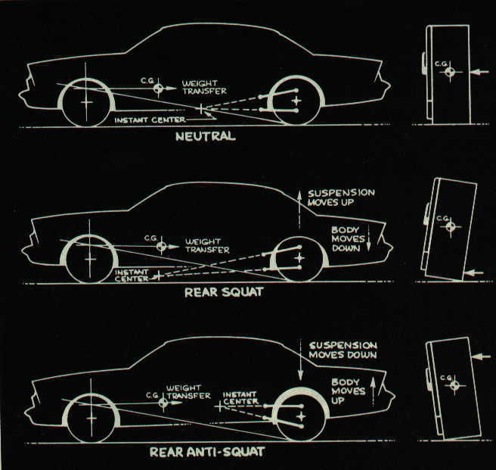

Chassis builders and tuners call this situation (over 100-percent anti-squat) "separation." That is, the rear axle "separates" from the chassis as it swings down and/or the body lifts up, and the springs and shocks extend. The point, of course, is to have the axle swing down (or at least try to as much as possible), thus "planting" or "shocking" the rear tyres on the ground. This is a dynamic situation, with many variables acting at once.

Of primary importance is that there be enough weight in the back of the car to make it work. This is a real concern in most “early” street rods. If the centre of gravity in the car is too far forward, a four-link or ladder bar adjusted to plant the rear tyres will simply lift the rear of the body instead. Most builders say you need at least 45-percent of the car's weight on the rear wheels to make a four-link work properly. Spring and shock rates will also influence the effects of the suspension "tune." Particularly important is the extension stiffness of the shocks. Increasing this stiffness decreases the effect of the separation, and vice versa. The same is true of spring rates. The main focus here is to understand that where a builder locates the instant centre of the rear suspension can have a positive or negative effect on how the car launches. A fully-adjustable four-link allows a chassis tuner to move the instant centre not only up or down, but also forward or back (by increasing or decreasing the angle between the bars) at the track.

The obvious question is "Where is the right point to set it?" I don't think there is any way to accurately calculate such a point in a drag car. There are too many dynamic variables. For one thing, when a high-powered race car launches, its front wheels are usually off the ground, so the standard engineering diagram for 100-percent anti-squat doesn't apply. Trying to calculate the "correct" instant centre for the four-link in your car is not the point. In fact, it's probably impossible, because as the chassis lifts in the front, the location of the centre of gravity changes; and, more significantly, as the rear suspension moves up or down, the instant centre of the four-link also changes. The shorter the bars, or the more angled they are, the more dramatic this change will be (unequal length bars also give the same effect), and thus the harsher the shock on the rear tyres will (usually) be.

The way most builders/tuners use the four-link is to set it at an adjustment they know from experience is in the ballpark for the given car; then they try some launches and observe (either by eye, or video camera) what the chassis and rear tyres do. The beauty of the four-link is that once you see what happens, you can adjust it several different ways. The chassis tuner has two primary concerns: the rear tyres should hook up without slipping, and the car should start moving forward as quickly as possible, rather than lifting, squatting, wheel standing, or other monkey business. If the rear of the car squats, he can raise the instant centre of the bars; if the rear lifts too much, he can lower the instant centre. If the car tends to wheel stand too much, he can angle the bars closer together at the front to move the instant centre further to the rear of the car; if the tyres are being shocked too violently (as in a trans-brake car), he can do the opposite. This is oversimplifying, of course.

Considering shock and spring adjustments plus changes to the front suspension that can affect the rear, the four-link might seem like a complicated nightmare. It's not. It helps you to get a car dialed-in for the best possible launches. Once dialed-in, it lets you adjust the car for varying track or other conditions.

There's another phenomenon common to front-engine, rear-drive cars. It, too, is an action/reaction, inertia/momentum situation, but it operates side-to-side in the car, rather than front-to-back. It is caused by the fact that the crankshaft and drive shaft rotate along a north-south axis while the rear axles and wheels rotate on an east-west axis. Actually, it is two separate problems, only moderately related. The first, of which you are probably aware, is the tendency of the engine to try to lift the left front corner of the chassis as the car launches. That's because the crankshaft is trying to turn clockwise (viewed from the front), but the car's inertia is holding it back (see illustration next page). As the engine strains against this resistance, it reacts by trying to spin (counterclockwise) around the crankshaft. Since the engine is (hopefully) anchored securely to the frame, it tries to pull the frame up on the left (passenger's) side. The more powerful the engine, and the heavier the car, the more pronounced the problem becomes.

The solution is to build a chassis that doesn't twist, or to stiffen and triangulate the one you have as much as possible. Actually, it's something most chassis tuners don't worry about too much. If it isn't excessive and the car goes straight let it happen. Trying to tune it out with the rear suspension can lead to worse side effects.

The other problem due to drive shaft rotation is less obvious, but more severe. The drive shaft rotates clockwise as it drives the pinion in the third member. When inertia holds the car from moving and the tyres are stuck firmly to the ground, the rotating drive shaft actually tries to turn the entire rear end in the same clockwise direction. This effect is usually not apparent to the eye, but it does tend to lift the right rear tyre slightly, and plant the left rear more firmly. You have undoubtedly witnessed the result of this in the typical street machine. If you sidestep the clutch in a car with a live rear axle and unlocked differential, it will smoke the right rear tyre. (A car with a chassis-mounted third member, such as a Corvette or Jaguar IRS, avoids this problem.) In a race car, any imbalance in traction, right to left, can send the car veering off the starting line at an angle. It doesn't take much when one big sticky slick hooks up more than the other does. Many race cars do tend to pull to the right off the line because the drive shaft twist on the rear end is unloading the right rear tyre slightly. One way to combat this is to place more chassis weight (battery, fuel tank, ballast, etc.) in the right rear corner of the trunk. However, this weight doesn't act directly on the tyre, because it is suspended. It only shifts the centre of gravity of the car.

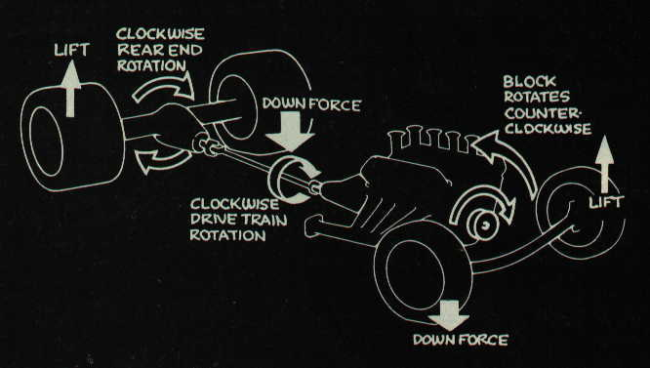
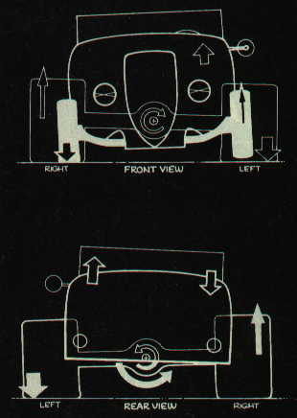
With a four-link suspension, however, you can effectively place more weight directly on one rear tyre. This practice is known as "pre-loading," and is commonly done with the upper right bar to pre-load the right rear tyre. Hopefully the bar has left and right threaded rod ends and a hex fitting on the bar, so that turning it in one direction shortens its length, and turning it the other lengthens it. Shortening the upper right bar adds weight to the right rear tyre. A little does a lot. One-quarter turn can add as much as 50 pounds. You can get the same effect on the right rear tyre by lengthening the lower right bar, or even the upper left bar. Obviously you only want to pre-load one bar out of the four. Do it sparingly.

Another method is to install a stabiliser bar that misuses body movement and places equal amounts of force on the rear tyres. I’ll send you literature on the dynamics involved with a rear stabiliser bar as soon as Hugo is E-mail enabled.

